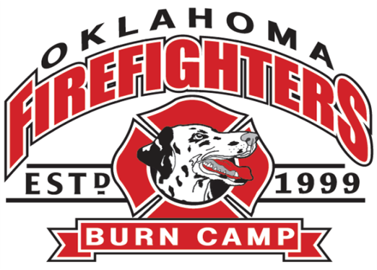
2024
July 31- August 4, 2024
This year’s theme: Olympics

CAMP EGAN 26633 US-62, Tahlequah, OK 74464

This will be our 26th annual camp for burn survivors between 6 and 16 years of age. Burn camp check in will start Camp Egan at 2:30 pm. Those that prefer a ride from the Tulsa area will meet the bus at the Akdar Shrine at 2808 S. Sheridan Rd, Tulsa OK. Check in at Akdar will be 1230 pm. The bus will leave for Camp Egan at 1:15. Please indicate on the 3rd page of this application where your child will be checking in to camp.

Camp will conclude with a closing ceremonies celebration on Sunday, August 4th. Parents or Guardians are asked to meet at the Camp Egan Valley View Center parking lot at 10:00 a.m. The celebration will conclude by 11:45 a.m.

In order for camp to be an exciting and impactful experience for everyone, the following lists are provided for things to bring as well as things not to bring to camp.
Items to bring to camp:
- 5 to 6 sets of clothes
- Neon/Glow in the dark themed outfit for the dance (optional)
- Sleep Wear
- Swimsuit (modest suits preferred) & cover up
- Hat
- Light Jacket or sweatshirt – Just In Case!
- Tennis Shoes – It’s possible they will get wet
- Toiletry Items – Soap, shampoo, toothbrush, toothpaste, hairbrush, deodorant
- Pillow (Please write your child’s name on the tag of the pillow)
- Swim shoes or old tennis shoes for getting in the creek (it is very rocky)
- Linens WILL BE provided (Sheet set, towels, wash cloths)
- All Medical Supplies – Please fill out Medical Form completely
- MOST IMPORTANTLY – A POSITIVE ATTITUDE!!
Items Not To Bring to camp:
- Expensive items, Electronics, Knives/Guns, Alcohol/Tobacco products, Fireworks, Silly string, Balloons

For questions or assistance with transportation contact assistant director Jennifer Parham @ (918) 698-8812, email director@okffburncamp.org. Please try to call for transportation assistance by July 24th, if possible.
PLEASE KEEP THIS PAGE. ONLY RETURN THE FOLLOWING 3 PAGES. THANK YOU!

2024
Camper Medical information

Last Name: _______________________________ First Name: _____________________________

Date of birth____/____/____ (MM/DD/YY) Gender at birth ______ Gender identity____________

Medication brought to camp must be checked in with the camp nurses. Please list medications and instructions below.
Medication | Dosage | Special Instructions

Please list Allergies below:
Allergy | Reaction

Information about burns or injury: Describe injury and any current treatment

Parent or guardian name______________________________________________________________

Home phone: _(______)_____________________ Cell: __(______)___________________

Medical insurance _______________________________________________________

Preferred Hospital in case of emergency: (closest to Camp Egan is Tahlequah City Hospital)
__________________________________________________________

Emergency contact Name: ______________________________ Phone: (______)_____________________

Give camper Tylenol for pain, headache or fever _____yes_____no
Give camper Ibuprofen for anti-inflammatory or fever _____yes_____no
Give camper Mylanta for upset stomach and or diarrhea ____yes_____no
Give camper Benadryl for (possible) allergic reactions _____yes_____no

Parent or guardian signature_____________________________________Date_____/_____/____
2024

I would like my child______________________________, DOB _______/_______/_______to participate in the Oklahoma Firefighters Burn Camp. I consent to such participation. I understand that my child’s medical history will be reviewed by camp medical staff in order to develop my child’s particular plan for camp participation. I agree and authorize the release of my child’s medical information for this purpose and for the event of an emergency. I authorize the camp staff to provide necessary medical treatment for my child while at camp. I recognize that there always exists the possibility of personal injury and or property damage or loss of any kind during camp. In consideration of my child being permitted to participate, I hereby release and hold harmless, Oklahoma Firefighters Burn Camp, staff and volunteers, all transportation personnel, Camp Egan and staff, Akdar Shrine, all fishermen and boat owners and any other affiliates of Oklahoma firefighters Burn Camp from any and all liability for bodily injury and or property damage or loss arising out of or in connection with my child’s participation at camp.
I hereby give permission for the above named child to be photographed (by still, movie or television camera). I also give permission for these images to be used for purpose of illustration, advertising, publicity or publication in any manner.

Parent or Guardian information

Last Name: ______________________________ First Name: ______________________________

Address________________________________________________________________

City_____________________________ State______________________ Zip___________
Cell Phone:(___)______________________Email address ________________________________________

Tribe _______________ Tribal number ______________
(this information allows partnership with the tribes to improve accessibility at camp)

Signature of parent or Guardian________________________________________ Date: __________

My child will check in to Burn Camp at:

______ Camp Egan 26633-62, Tahlequah, OK 74464 at 230 pm

______ Akdar Shrine at 2808 S. Sheridan Rd. Tulsa, OK 74129 on at 1230 pm

______ My child needs transportation to camp

______ My child needs transportation home

Does your child have a counselor preference? List their name here:________________________________

We are honored to be able to continue our mission of providing unconditional love and acceptance to our burn survivors and provide one new outfit for each camper to start school. Please fill out the sizes listed below as you would anticipate your child to need in August.

Childs name __________________________ Age ______

Please indicate adult or child sizes below

Shirt size ___________

Jeans size __________ Jogger or athletic pants size __________

Shoe size __________

Favorite Color ____________________

Favorite theme/hobbies/activities

___________________________________________________________________

Anything we need to know when purchasing clothing for your child?

